Cloud Computing Practical Assignment No 6

Working and Implementation of Identity and Access Management (Using AWS) Prepare Screen shots file and write down the steps. Make single word or PDF file .

Task 1: Explore Users and Groups

1. Open IAM Console:

In the search bar, type IAM and open the IAM console.

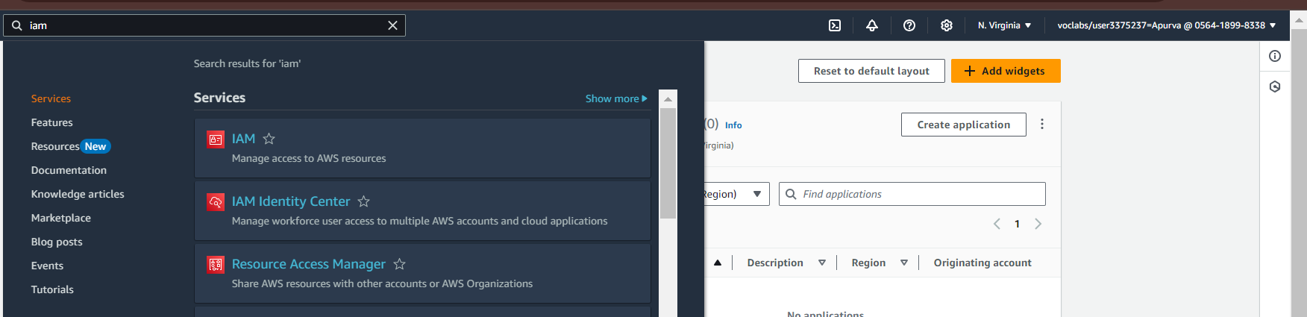

2. View Users:

On the left, click Users. Three users are created:

- user-1

- user-2

- user-3

3. Check user-1:

- Click user-1 to see the summary page.

- In the Permissions tab, notice that user-1 has no permissions.

- Go to the Groups tab; user-1 is not part of any group.

- Go to Security credentials tab; user-1 has a console password.

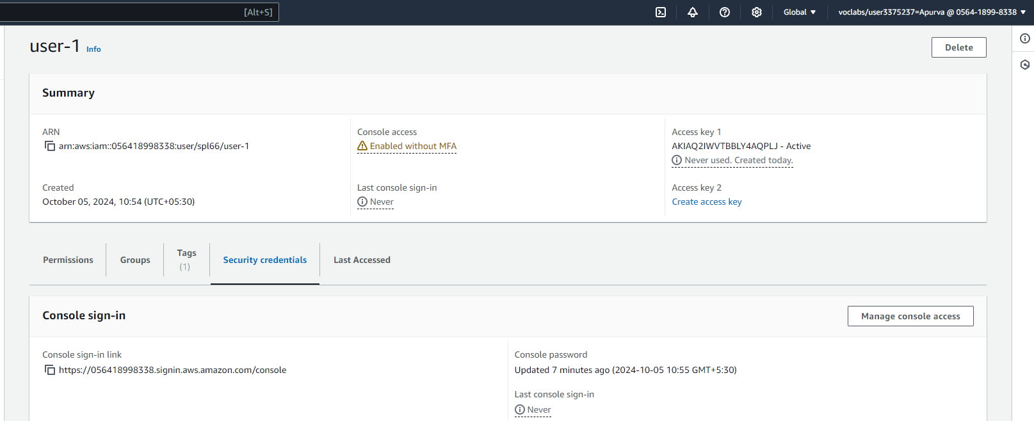

4. View User Groups:

On the left, click User groups. Three groups are created:

- EC2-Admin

- EC2-Support

- S3-Support

5. Check EC2-Support Group:

- Click EC2-Support.

- Go to the Permissions tab and see the policy AmazonEC2ReadOnlyAccess.

- Click the + to view details.

The policy allows viewing EC2 resources, but not changing them.

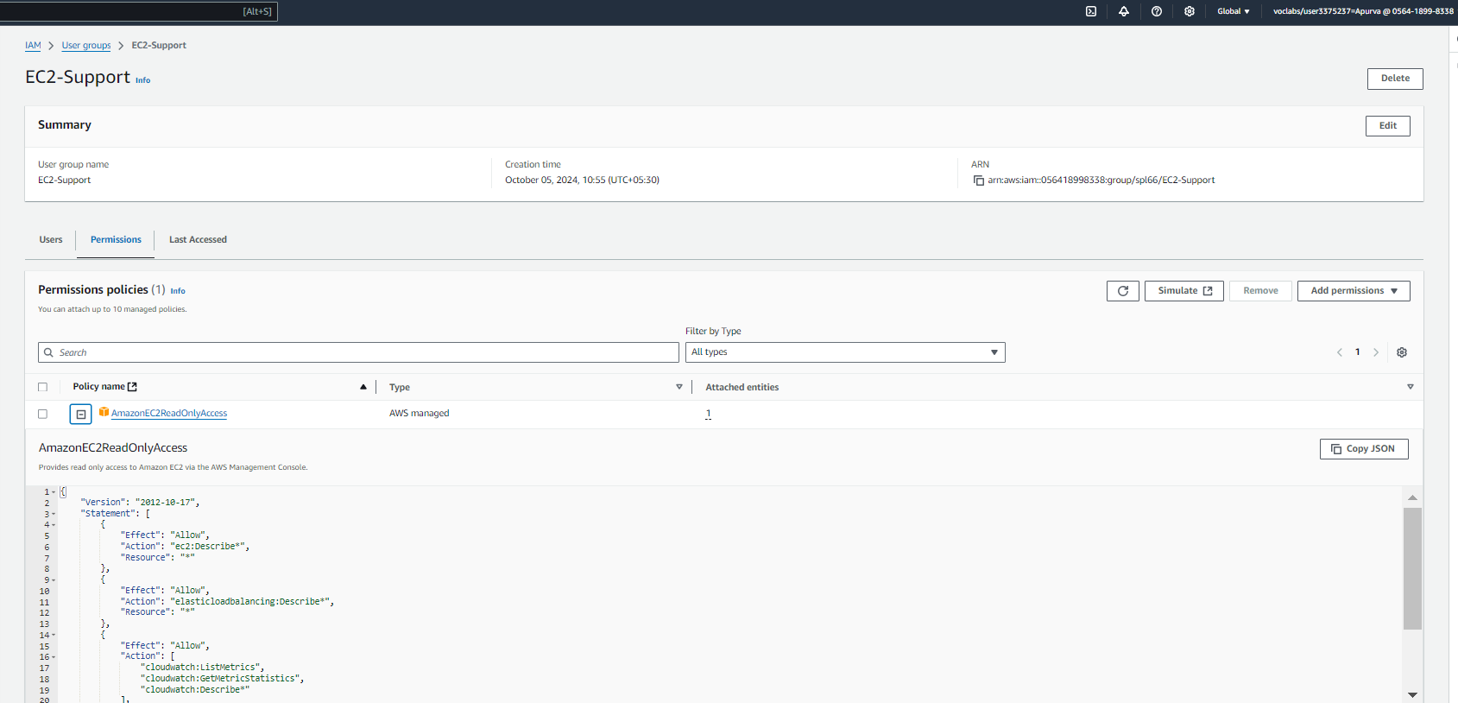

- Click the - to hide details.

6. Check S3-Support Group:

- Click S3-Support.

- Go to the Permissions tab and see the policy AmazonS3ReadOnlyAccess.

- Click the + to view details.

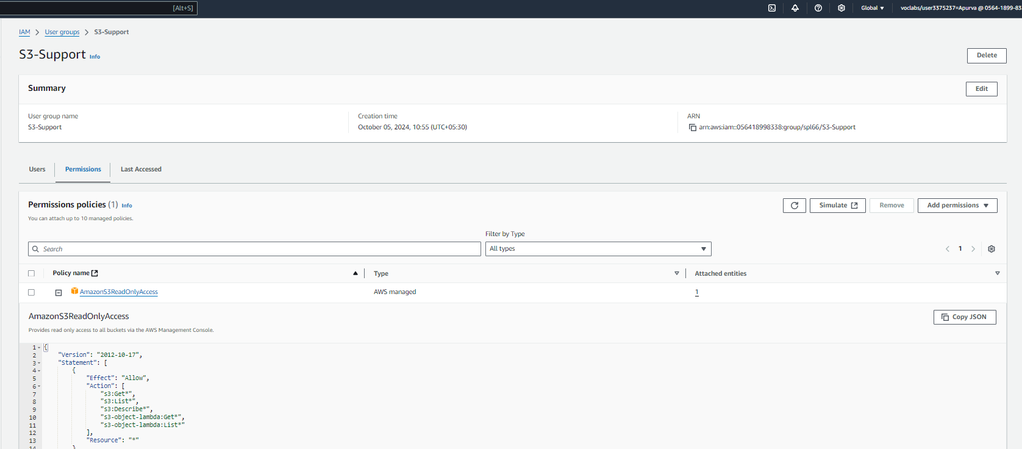

The policy allows viewing S3 resources.

- Click the - to hide details.

7. Check EC2-Admin Group:

- Click EC2-Admin.

- Go to the Permissions tab and see it has an Inline Policy.

This policy allows starting and stopping EC2 instances.

- Click the + to view details, and the - to hide details.

Task 2: Add Users to Groups

1. Add user-1 to S3-Support Group:

- On the left, click User groups.

- Click S3-Support, then go to the Users tab.

- Click Add users.

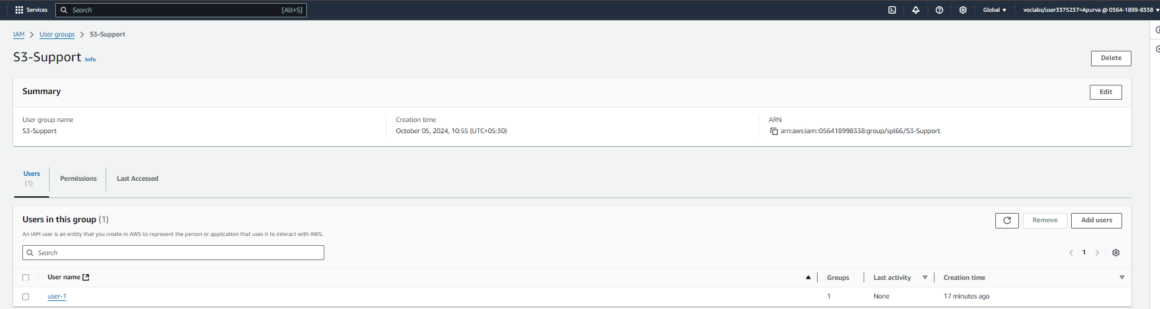

- Select user-1 and click Add users.

2. Add user-2 to EC2-Support Group:

- Repeat the same steps to add user-2 to EC2-Support.

3. Add user-3 to EC2-Admin Group:

- Repeat the same steps to add user-3 to EC2-Admin.

4. Check Users in Groups:

- Go to User groups and ensure each group has 1 user assigned.

Task 3: Sign In and Test Users

1. Get Sign-in Link

- Go to the Dashboard.

- Copy the Sign-in URL shown on the right.

2. Test user-1 (S3 Support):

- Open a Private/Incognito window.

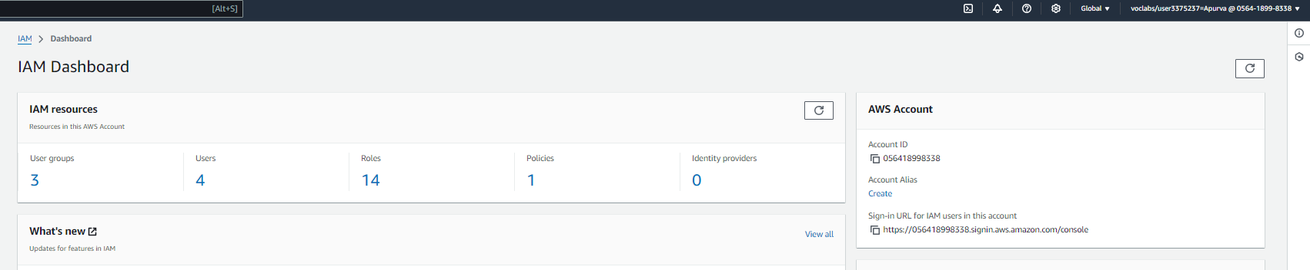

- Paste the Sign-in URL and log in as user-1 using password Lab-Password1.

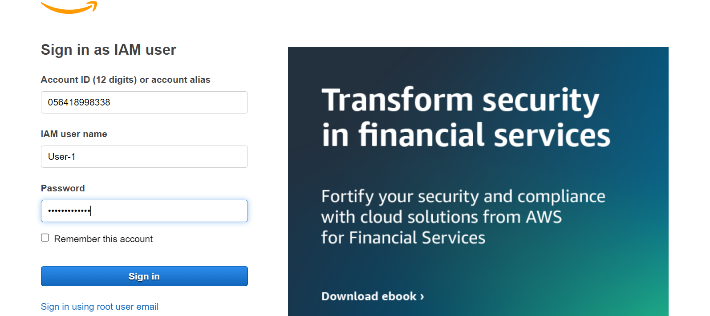

- Search for S3 in Services and view the S3 bucket.

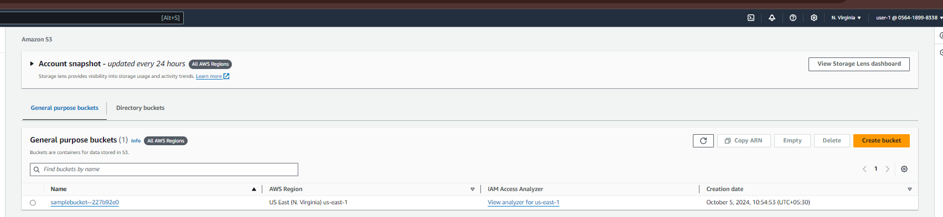

- Search for EC2 in Services and notice you cannot see any instances.

3. Test user-2 (EC2 Support):

- Log out of user-1 and log in as user-2 with password Lab-Password2.

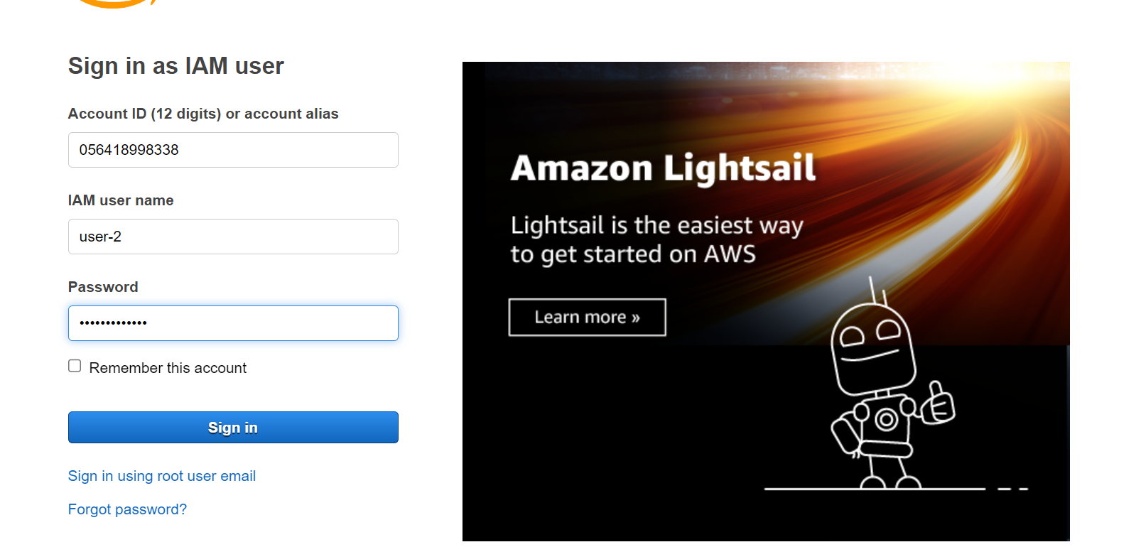

- Search for EC2, view the EC2 instance, but you cannot stop it.

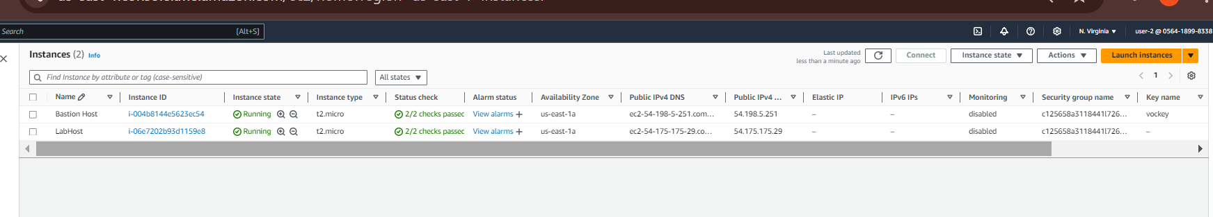

- Search for S3 and notice you cannot access S3 buckets.

4. Test user-3 (EC2 Admin):

- Log out of user-2 and log in as user-3 with password Lab-Password3.

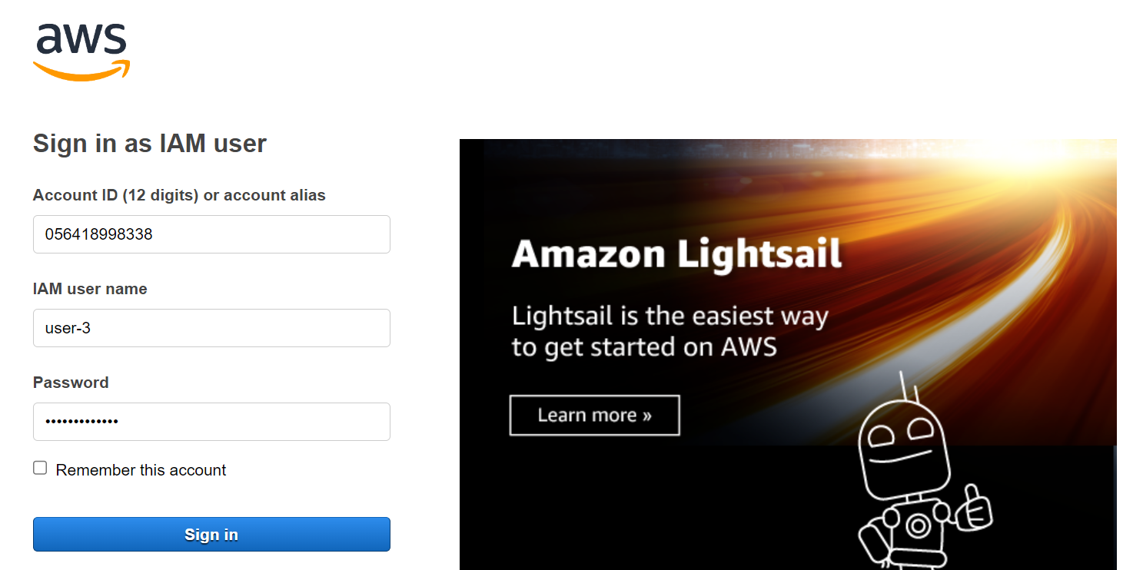

- Search for EC2 and stop the EC2 instance.

